От: Vladimir_Markus@dell.com
Отправлено: 12 июля 2016 г. 16:59
Кому: Belogrud Sergey Vladimirovich; Pavlov Dmitriy Stanislavovich; Piotr_Kretkiewicz@Dell.com
Копия: Nemchin Dmitriy Yuryevich; Bezrukikh Georgiy Gennadyevich; Kartsev Konstantin; Ovchinnikov Dmitriy Sergeevich; Aleksandrov Aleksey Valerievich; Chernyh Aleksandr Vladimirovich; Leonov Aleksey Vladimirovich; Shinkarev Arkadiy Sergeevich; Terentev Aleksey; Zbiranik Evgeniy Aleksandrovich
Тема: RE: Dell Support Case: 932140477 [R730xd] HDDs performance down

Категории: Оранжевая категория; Желтая категория

Dell - Internal Use - Confidential
Сергей, Дмитрий,

В моих интересах решить Вашу проблему, но для этого мне необходимо знать в чем именно она, можем ли мы исключить факторы (OS, Network итд.), влияющие на производительность помимо железа?

Давайте запустим IOMeter, и посмотрим на результаты, так же предлагаю после этого собрать еще раз логи, возможно во время интенсивного теста увидим что то в логах контроллеров.

Environment
Iometer is both a workload generator (it performs I/O operations in order to stress the system) and a measurement tool (it examines and records the performance of its I/O operations and their impact on the system). It can be configured to emulate the disk or network I/O load of any program or benchmark, or can be used to generate entirely synthetic I/O loads. It can generate and measure loads on single or multiple (networked) systems.

Description:

The tool consists of two programs, Iometer and Dynamo.

- Iometer is the controlling program. Using Iometer's graphical user interface, you configure the workload, set operating parameters, and start and stop tests. Iometer tells Dynamo what to do, collects the resulting data, and summarizes the results in output files. Only one copy of Iometer should be running at a time; it is typically run on the server machine.
- Dynamo is the workload generator. It has no user interface. At Iometer 's command, Dynamo performs I/O operations and records performance information, then returns the data to Iometer . There can be more than one copy of Dynamo running at a time; typically one copy runs on the server machine and one additional copy runs on each client machine.

Installation of Iometer
- First you have to download Iometer from Iometer.org.
Note: For Windows 2008 and above, download Version 1.1.0. For older Windows editions use Version 2006.07.27.
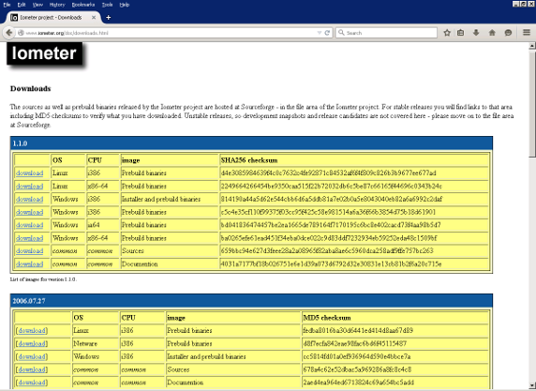
Figure 1.1: Iometer download page

2. Right click the setup file and then click on Run as administrator
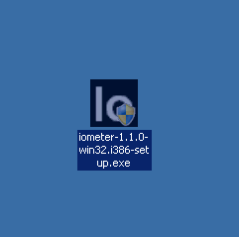
Figure 1.2: Iometer file on desktop

3. Accept the UAC request.
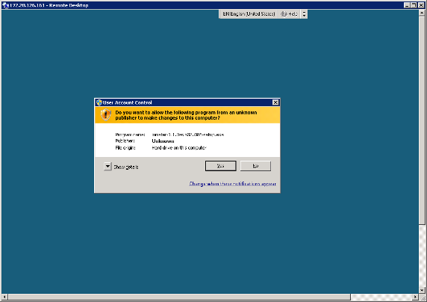
Figure 1.3: UAC request

4. Click Next > on the Welcome screen.
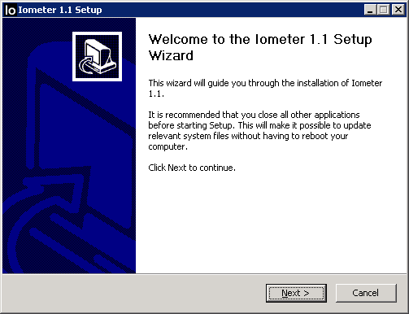
Figure 1.4: Welcome screen

5. Agree license agreement
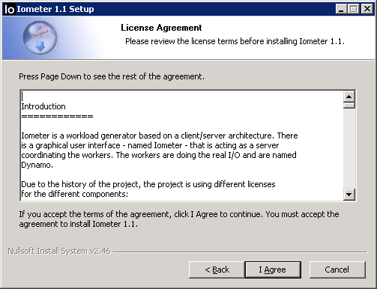
Figure 1.5: license agreement

6. Select the componentes that should be installed and click Next
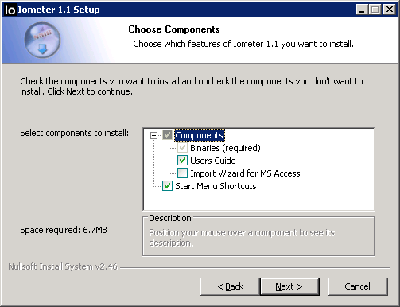
Figure 1.6: Choose Components

7. Select the installation destination and click Install
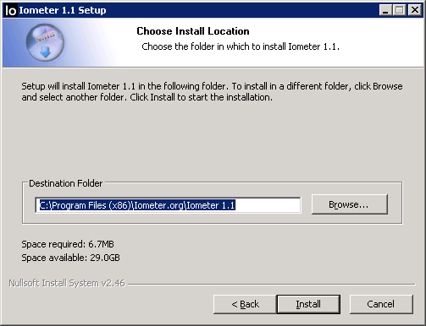
Figure 1.7: Define destination folder

8. When installation is done, click on Finish
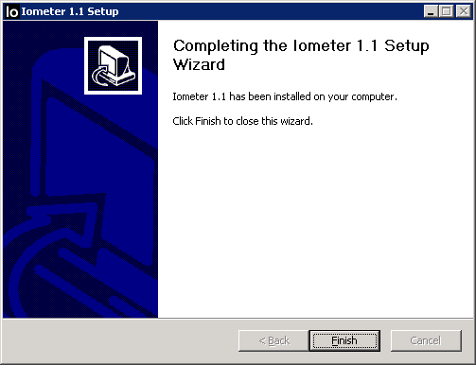
Figure 1.8: Finished installation

Start the test procedure in Iometer
1. Start Iometer

2. Agree the license conditions
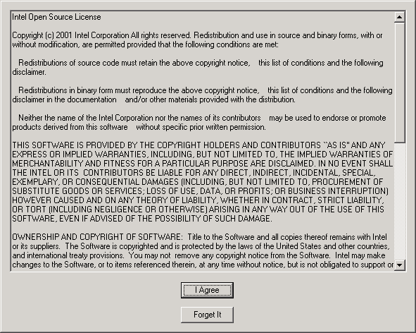
Figure 2.1: License conditions

3. Click on the folder button
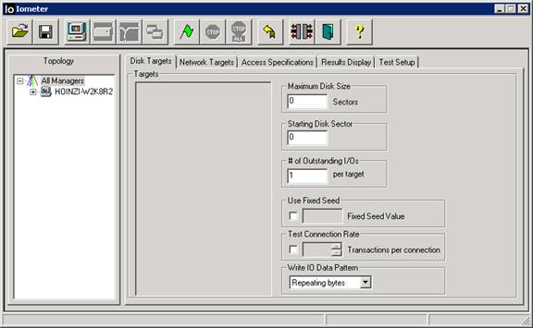
Figure 2.2: Folder button in upper left corner

Download the test configuration file SIM-Real-World-Workload-2.1.0.icf, and open it with Iometer .
Note: If you are using Iometer 2006.07.27, use Sim-Real-World-Workload-1.2.0.icf instead.
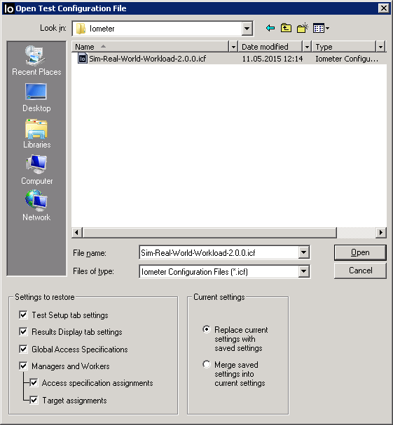
Figure 2.3: Choose configuration file

5. Choose the device to be tested
Warning: Unless instructed otherwise, use Iometer only on filesystems or data loss might occur!
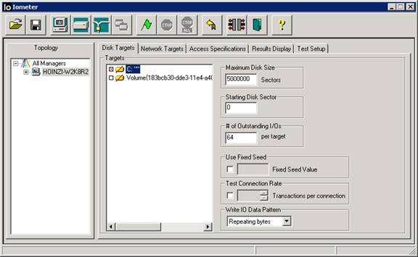
Figure 2.4: Choose device to be tested

6. Start the test by clicking on the green flag button
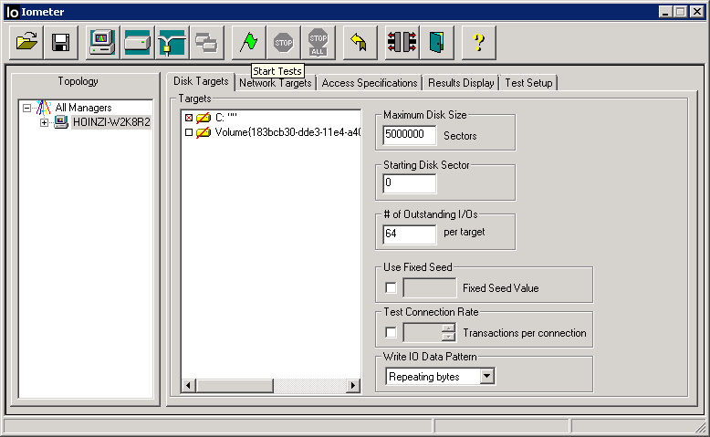
Figure 2.5: Green flag button in upper middle

7. Define the destination where to save the results file
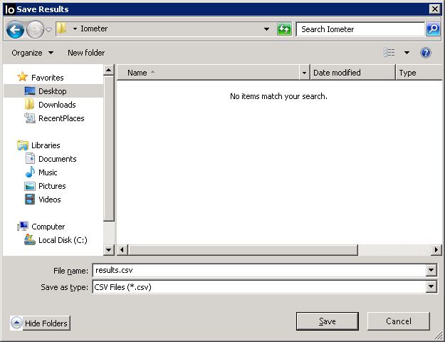
Figure 2.6: Choose destination for results

8. Now the test starts and will run for about 10-15 minutes
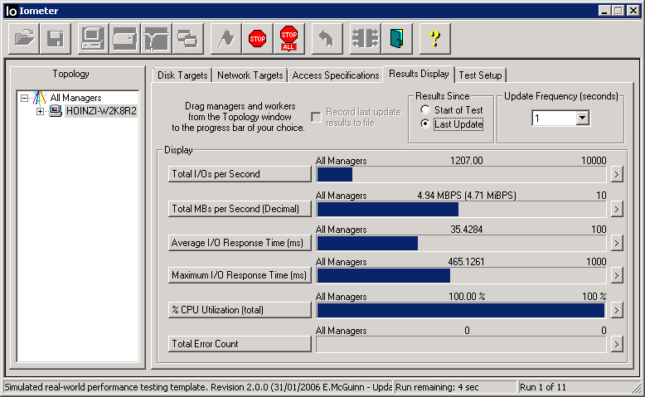
Figure 2.7: Running test

The program Iometer only runs on Windows OS. So on Linux systems the tool Dynamo is used for sending the relevant information to a Windows system, where Iometer is installed.
This means an installation of Iometer on a Windows system or Windows emulator is necessary for testing a system with Linux installed. Download Iometer from Iometer .org.
Note: The matching Dynamo files are included in the Iometer archives on Iometer .org.
Installation of Iometer and Dynamo
1. First Install Iometer on a windows system in the same network as the server you want to test.
If there is no Windows client available to run the Iometer .exe, it can be run with WinE emulator as well.
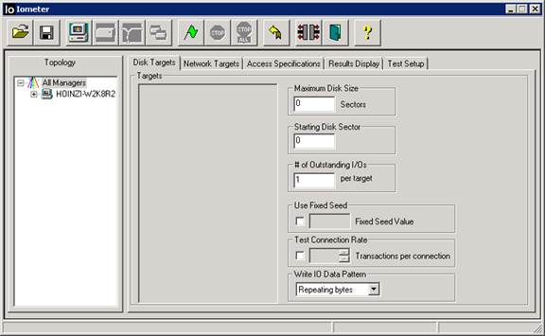
Figure 3.1: Iometer GUI

2. Connect via SSH to linux server (e.g. via Putty)
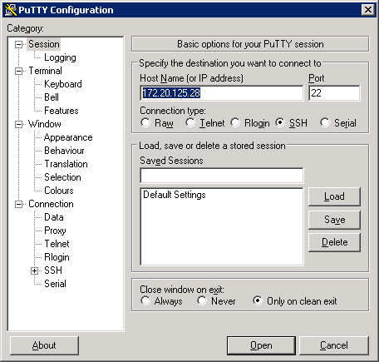
Figure 3.2: Putty

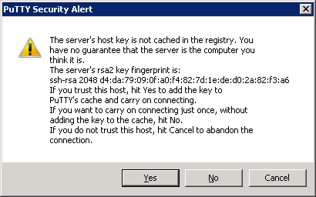
Figure 3.3: Click Yes

3. Login in to the server
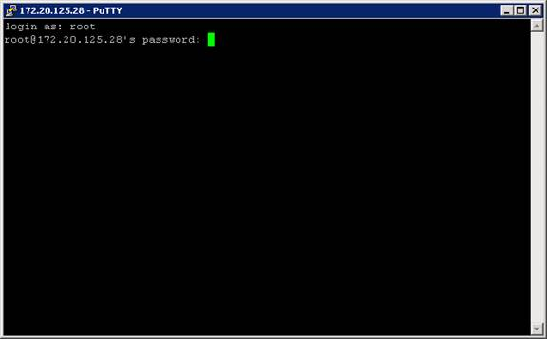
Figure 3.4: Console via Putty

4. Use uname -i to receive information about the hardware platfom, which is necessary to choose the right version of Dynamo.
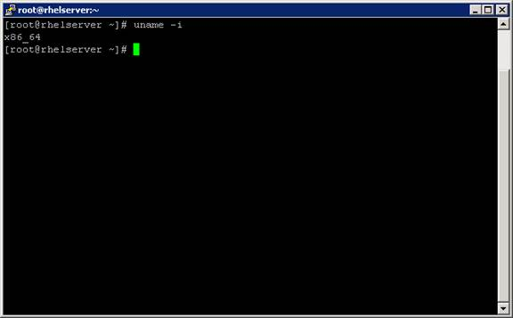
Figure 3.5: Check hardware version

5. With rpm -qa|grep -i glibc you check the installed version of glibc
Note: glibc 2.15 or above is needed to run with Iometer 1.1.0. Otherwise use 2006.07.27
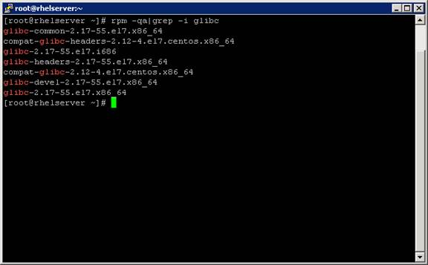
Figure 3.6: Command output

6. Switch to the /tmp folder
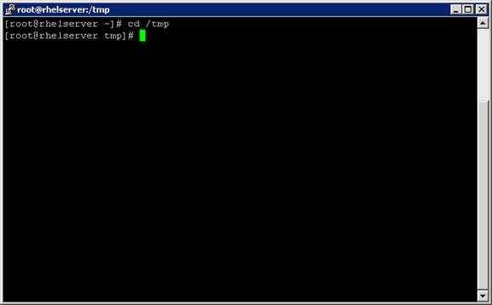
Figure 3.7: /tmp folder

7. Uncompress the downloaded Iometer file with tar xvf Iometer -1.1.0-linux.x86_64-bin.tar.bz2
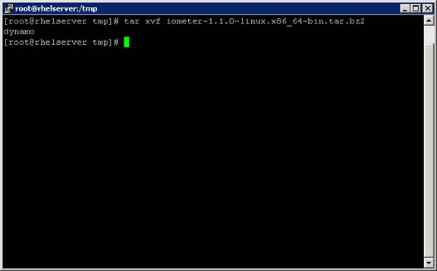
Figure 3.8: Uncompress the dynomo file

Start the test procedure
1. Check the IP address of the Windows system by using the CLI command ipconfig
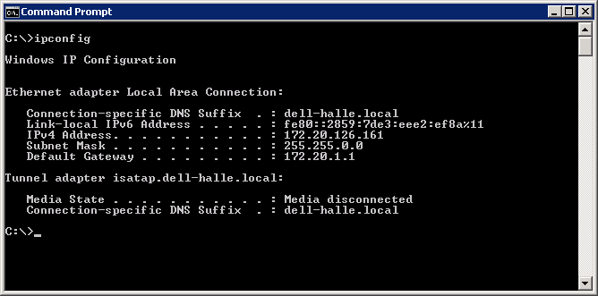
Figure 4.1: Check IP of Windows system

2. Check the IP addresses of the Linux system with ip addr show or ifconfig -a
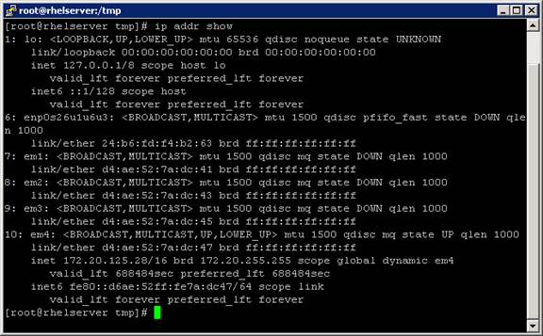
Figure 4.2: Check IP of Linux system

3. Stop the Linux firewall to allow communication between Dynamo and Iometer
Note: Commands to stop the Linux Firewall are:
SuSE based: rcSuSEfirewall2 stop
RHEL based: service iptables stop or systemctl stop firewalld
Debian based: service iptables stop
Ubuntu based: ufw disable
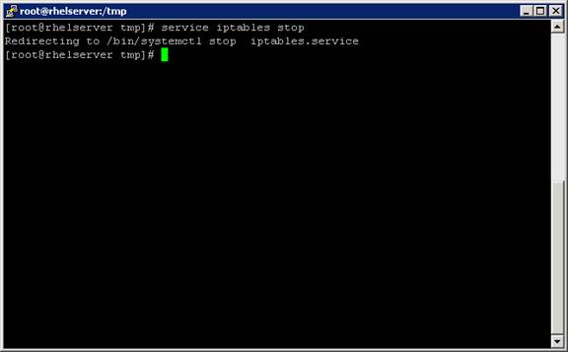
Figure 4.3: Stop firewall of Linux system

4. Type vi /etc/hosts to make changes on the host file for name resolving
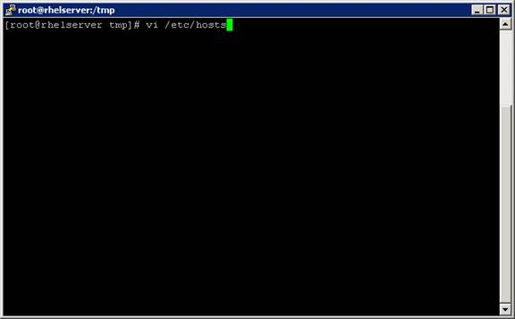
Figure 4.4: Open /etc/hosts

5. Add the ip address and the name of the Linux system
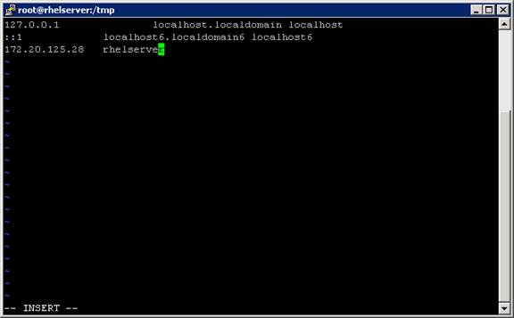
Figure 4.5: Add IP and name

6. Now connect dynamo with Iometer by using the command:
dynamo -i <IP of machine with Iometer = windows system> -m <IP of machine to run workload = linux system>
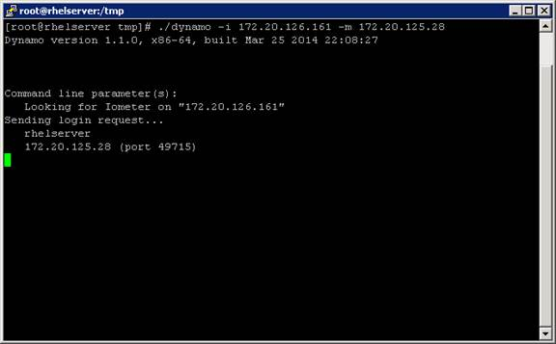
Figure 4.6: Connect dynamo to Iometer

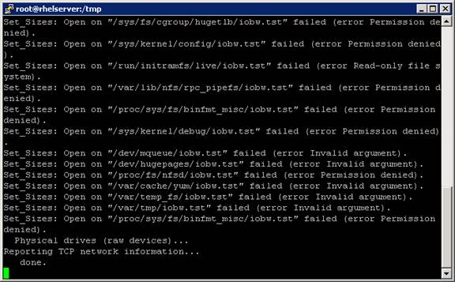
Figure 4.7: Connection established

7. In Iometer now the linux sever is visible
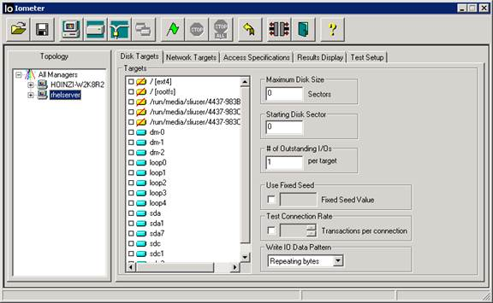
Figure 4.8: Linux system listed in Iometer

8. Before loading the test template Sim-Real-World-Workload-2.1.0.icf, some changes must be done on the file.
Note: If you are using Iometer 2006.07.27, use Sim-Real-World-Workload-1.2.0.icf instead.
Open the file in an editor (e.g. Notepad). Change the Manager name and Manger network adress by using the information you used in step 5. Save the file when changes are done.
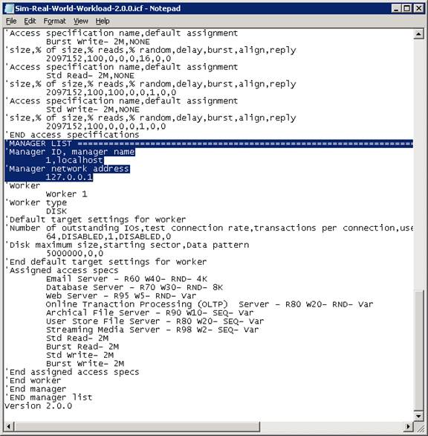
Figure 4.9: Search MANAGER LIST

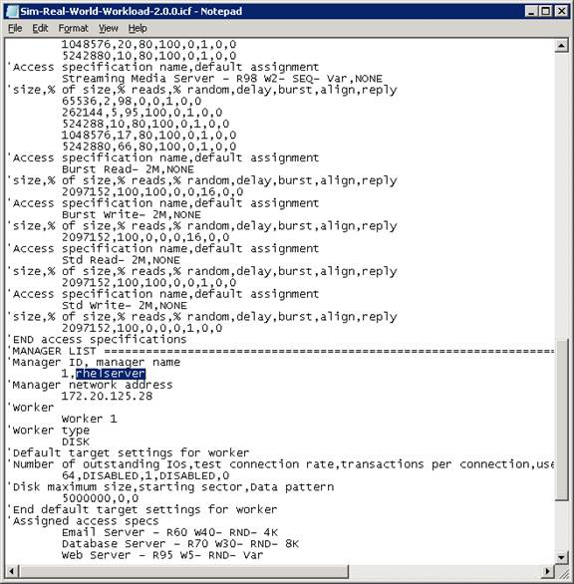
Figure 4.10: Add Linux server name

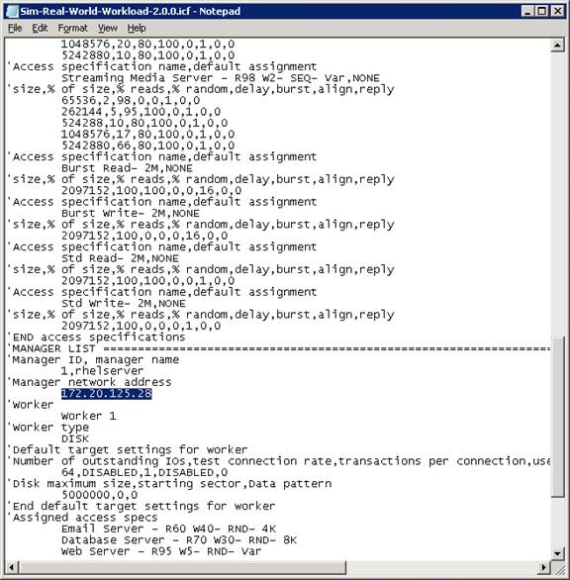
Figure 4.11: Add Linux server IP address and save file

9. Load the changed template
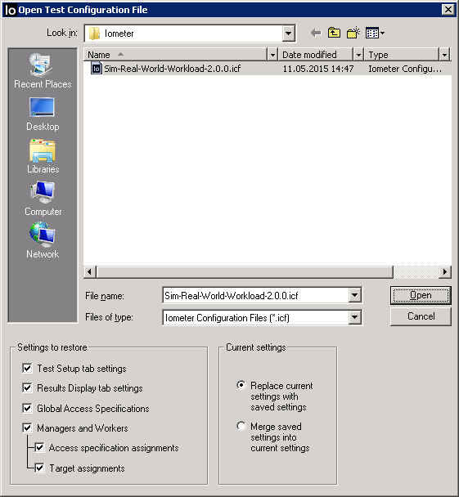
Figure 4.12: Load configuration file

10. Choose the device to be tested
Warning: Unless instructed otherwise, use Iometer only on filesystems or data loss might occur!
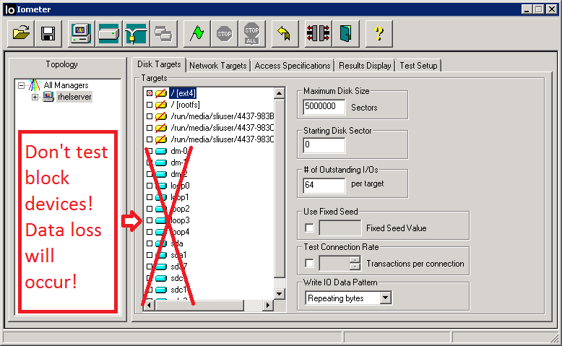
Figure 4.13: Choose device to be tested

11. Start the test by clicking the green flag button
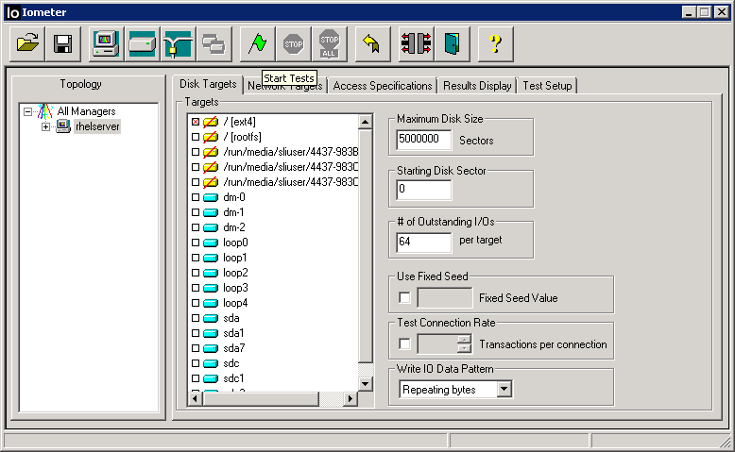
Figure 4.14: Green flag in the upper middle

12. Choose the destination where the results shall be saved after testing.
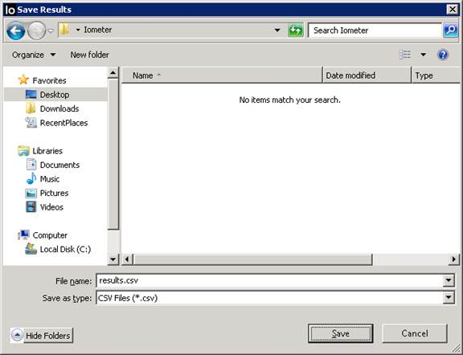
Figure 4.15: Choose destination for results

13. Now the test starts
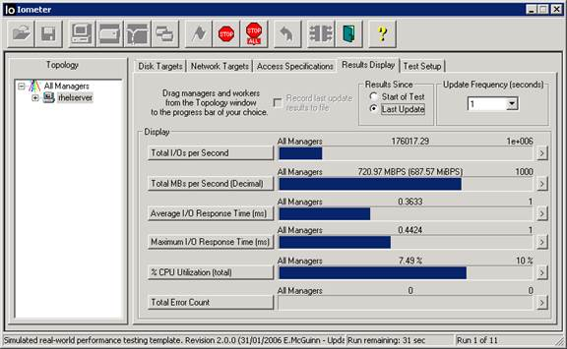
Figure 4.16: Running test

When the test is done..
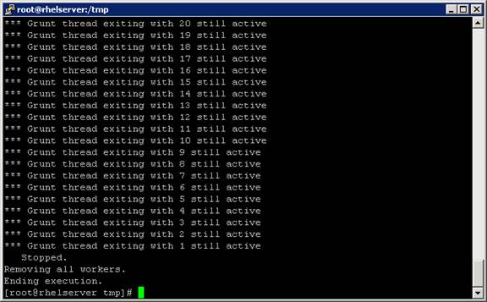
Figure 4.17: Finished test in console view

…don’t forget re-activate the firewall, delete the information from /etc/host (undo step 5) and then exit.
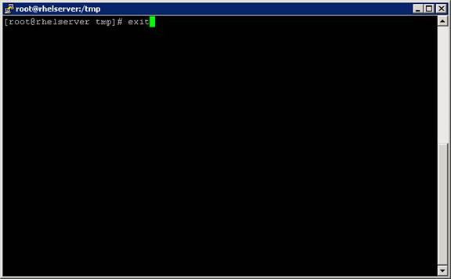
Figure 4.18: Exit console

Mit freundlichen Grüßen / Best Regards / С уважением
Vladimir Markus
Enterprise Resolution Manager

Dell | Global Support & Deployment
Deskphone – Internal: 3125005 External: +4934578225005
vladimir_markus@dell.com
Dell Halle GmbH in Vertretung der Dell GmbH. Raffineriestraße 28, 06112 Halle (Saale), Germany

Geschäftsführer: Doris Albiez, Sanjay Tyagi
Vorsitzender des Aufsichtsrates: Jürgen Renz
Eingetragen beim Amtsgericht Stendal unter HRB 215298, USt.-ID: DE242553389
WEEE-Reg.Nr. der Dell GmbH: DE 49515708

How am I doing ? Email my manager Tino Buttenberg with any feedback.

From: Belogrud Sergey Vladimirovich [mailto:s.belogrud@tinkoff.ru]
Sent: Tuesday, July 12, 2016 3:39 PM
To: Pavlov Dmitriy Stanislavovich <d.s.pavlov@tinkoff.ru>; Markus, Woldemar <Vladimir_Markus@dell.com>; Kretkiewicz, Piotr <Piotr_Kretkiewicz@Dell.com>
Cc: Nemchin Dmitriy Yuryevich <d.nemchin@tinkoff.ru>; Bezrukikh Georgiy Gennadyevich <g.bezrukikh@tinkoff.ru>; Kartsev Konstantin <k.kartsev@tinkoff.ru>; Ovchinnikov Dmitriy Sergeevich <d.ovchinnikov@tinkoff.ru>; Aleksandrov Aleksey Valerievich <a.v.aleksandrov@tinkoff.ru>; Chernyh Aleksandr Vladimirovich <a.chernyh@tinkoff.ru>; Leonov Aleksey Vladimirovich <a.leonov@tinkoff.ru>; Shinkarev Arkadiy Sergeevich <a.shinkarev@tinkoff.ru>; Terentev Aleksey <a.terentyev@tinkoff.ru>; Zbiranik Evgeniy Aleksandrovich <e.zbiranik@tinkoff.ru>
Subject: RE: Dell Support Case: 932140477 [R730xd] HDDs performance down

Добрый день коллеги.

От себя могу констатировать о том факте, что после замены подозрительного диска (если с диском угадали) у коллег прикладников трудности с производительностью их приложения (GreenPlum) пропадают. В точности аналогичная трудность имеется и с серверами HP.

From: Pavlov Dmitriy Stanislavovich
Sent: Tuesday, July 12, 2016 4:35 PM
To: Vladimir_Markus@dell.com; Belogrud Sergey Vladimirovich; Piotr_Kretkiewicz@Dell.com
Cc: Nemchin Dmitriy Yuryevich; Bezrukikh Georgiy Gennadyevich; Kartsev Konstantin; Ovchinnikov Dmitriy Sergeevich; Aleksandrov Aleksey Valerievich; Chernyh Aleksandr Vladimirovich; Leonov Aleksey Vladimirovich; Shinkarev Arkadiy Sergeevich; Terentev Aleksey; Zbiranik Evgeniy Aleksandrovich
Subject: RE: Dell Support Case: 932140477 [R730xd] HDDs performance down

Владимир,
Я лишь утверждаю, что на лицо деградация двух дисковых массивов. О причине я могу только догадываться, хотелось бы услышать её от вас J Возможно, догадки есть у моего коллеги Сергея Белогруда.
Я понимаю, что на первый взгляд для вас всё выглядит хорошо (ошибок нет, в логах тишина). Однако, ключевым параметром для нас является именно производительность, а не отсутствие ошибок. Бизнес-пользователи логов не видят J
Если для того, чтобы признать проблемы на этих массивах, вам нужно провести дополнительные тесты (IOMeter) – давайте их проведём.
Что требуется от нас?

From: Vladimir_Markus@dell.com [mailto:Vladimir_Markus@dell.com]
Sent: Tuesday, July 12, 2016 4:22 PM
To: Pavlov Dmitriy Stanislavovich; Belogrud Sergey Vladimirovich; Piotr_Kretkiewicz@Dell.com
Cc: Nemchin Dmitriy Yuryevich; Bezrukikh Georgiy Gennadyevich; Kartsev Konstantin; Ovchinnikov Dmitriy Sergeevich; Aleksandrov Aleksey Valerievich; Chernyh Aleksandr Vladimirovich; Leonov Aleksey Vladimirovich; Shinkarev Arkadiy Sergeevich; Terentev Aleksey; Zbiranik Evgeniy Aleksandrovich
Subject: RE: Dell Support Case: 932140477 [R730xd] HDDs performance down

Dell - Internal Use - Confidential
Добрый день, Дмитрий, коллеги,

Смотрим что нашли по этим серверам:

GJCV762 -> ds-gp-prd-sdw13 -> Результат анализа логов -> No Disk error logged at all.
HKCV762 -> ds-gp-prd-sdw24 -> С этого сервера логи мы даже не получали, или произошла ошибка

Но даже если бы среди них был сервер, котором присутствовали пару ошибок, которые были скорректированы и произошли в марте/апреле, это бы не давало повод говорить, что проблема тут именно в дисках.

Я еще раз поговорил с техническими специалистами, которые подтвердили, что проблем с железом в логах не обнаружено.

Мы можем конечно запустить IOMeter и посмотреть на его результаты, но на данный момент я не могу диагностировать проблему с hardware.

Вы думаете, что эти проблемы возникают из за нескольких медиа ошибок на дисках?

Mit freundlichen Grüßen / Best Regards / С уважением
Vladimir Markus
Enterprise Resolution Manager

Dell | Global Support & Deployment
Deskphone – Internal: 3125005 External: +4934578225005
vladimir_markus@dell.com
Dell Halle GmbH in Vertretung der Dell GmbH. Raffineriestraße 28, 06112 Halle (Saale), Germany

Geschäftsführer: Doris Albiez, Sanjay Tyagi
Vorsitzender des Aufsichtsrates: Jürgen Renz
Eingetragen beim Amtsgericht Stendal unter HRB 215298, USt.-ID: DE242553389
WEEE-Reg.Nr. der Dell GmbH: DE 49515708

How am I doing ? Email my manager Tino Buttenberg with any feedback.

From: Pavlov Dmitriy Stanislavovich [mailto:d.s.pavlov@tinkoff.ru]
Sent: Tuesday, July 12, 2016 1:48 PM
To: Markus, Woldemar <Vladimir_Markus@dell.com>; Belogrud Sergey Vladimirovich <s.belogrud@tinkoff.ru>; Kretkiewicz, Piotr <Piotr_Kretkiewicz@Dell.com>
Cc: Nemchin Dmitriy Yuryevich <d.nemchin@tinkoff.ru>; Bezrukikh Georgiy Gennadyevich <g.bezrukikh@tinkoff.ru>; Kartsev Konstantin <k.kartsev@tinkoff.ru>; Ovchinnikov Dmitriy Sergeevich <d.ovchinnikov@tinkoff.ru>; Aleksandrov Aleksey Valerievich <a.v.aleksandrov@tinkoff.ru>; Chernyh Aleksandr Vladimirovich <a.chernyh@tinkoff.ru>; Leonov Aleksey Vladimirovich <a.leonov@tinkoff.ru>; Shinkarev Arkadiy Sergeevich <a.shinkarev@tinkoff.ru>; Terentev Aleksey <a.terentyev@tinkoff.ru>; Zbiranik Evgeniy Aleksandrovich <e.zbiranik@tinkoff.ru>
Subject: RE: Dell Support Case: 932140477 [R730xd] HDDs performance down

Добрый день, Владимир, коллеги.
Проблема сохраняется. При равных IOPS:

Await, Queue length и % утилизации двух массивов (sdb на sdw24, sdw13) сильно выделяются:

Такая же картина наблюдается на ещё одном сервере с массивом sdc. Со временем таких серверов становится больше, а их деградация прогрессирует.
Какие наши дальнейшие шаги?

From: Vladimir_Markus@dell.com [mailto:Vladimir_Markus@dell.com]
Sent: Tuesday, July 12, 2016 10:34 AM
To: Belogrud Sergey Vladimirovich; Piotr_Kretkiewicz@Dell.com
Cc: Nemchin Dmitriy Yuryevich; Pavlov Dmitriy Stanislavovich; Bezrukikh Georgiy Gennadyevich; Kartsev Konstantin; Ovchinnikov Dmitriy Sergeevich; Aleksandrov Aleksey Valerievich; Chernyh Aleksandr Vladimirovich; Leonov Aleksey Vladimirovich; Shinkarev Arkadiy Sergeevich; Terentev Aleksey; Zbiranik Evgeniy Aleksandrovich
Subject: RE: Dell Support Case: 932140477 [R730xd] HDDs performance down

Dell - Internal Use - Confidential
Добрый день, Сергей,

Спасибо за информацию, тогда ждем от Вас новостей по факту результатов наблюдения.

Хорошего дня!

Mit freundlichen Grüßen / Best Regards / С уважением
Vladimir Markus
Enterprise Resolution Manager

Dell | Global Support & Deployment
Deskphone – Internal: 3125005 External: +4934578225005
vladimir_markus@dell.com
Dell Halle GmbH in Vertretung der Dell GmbH. Raffineriestraße 28, 06112 Halle (Saale), Germany

Geschäftsführer: Doris Albiez, Sanjay Tyagi
Vorsitzender des Aufsichtsrates: Jürgen Renz
Eingetragen beim Amtsgericht Stendal unter HRB 215298, USt.-ID: DE242553389
WEEE-Reg.Nr. der Dell GmbH: DE 49515708

How am I doing ? Email my manager Tino Buttenberg with any feedback.

From: Belogrud Sergey Vladimirovich [mailto:s.belogrud@tinkoff.ru]
Sent: Monday, July 11, 2016 9:12 PM
To: Markus, Woldemar <Vladimir_Markus@dell.com>; Kretkiewicz, Piotr <Piotr_Kretkiewicz@Dell.com>
Cc: Nemchin Dmitriy Yuryevich <d.nemchin@tinkoff.ru>; Pavlov Dmitriy Stanislavovich <d.s.pavlov@tinkoff.ru>; Bezrukikh Georgiy Gennadyevich <g.bezrukikh@tinkoff.ru>; Kartsev Konstantin <k.kartsev@tinkoff.ru>; Ovchinnikov Dmitriy Sergeevich <d.ovchinnikov@tinkoff.ru>; Aleksandrov Aleksey Valerievich <a.v.aleksandrov@tinkoff.ru>; Chernyh Aleksandr Vladimirovich <a.chernyh@tinkoff.ru>; Leonov Aleksey Vladimirovich <a.leonov@tinkoff.ru>; Shinkarev Arkadiy Sergeevich <a.shinkarev@tinkoff.ru>; Terentev Aleksey <a.terentyev@tinkoff.ru>; Zbiranik Evgeniy Aleksandrovich <e.zbiranik@tinkoff.ru>
Subject: RE: Dell Support Case: 932140477 [R730xd] HDDs performance down

Добрый день Владимир, Пётр.

Сегодня вечером проведены работы по обновлению firmware.
Коллеги наблюдают за производительностью.
В ближайшее время сообщат о своих наблюдениях.

From: Belogrud Sergey Vladimirovich
Sent: Monday, July 11, 2016 5:26 PM
To: 'Vladimir_Markus@dell.com'; Piotr_Kretkiewicz@Dell.com
Cc: Nemchin Dmitriy Yuryevich; Pavlov Dmitriy Stanislavovich; Bezrukikh Georgiy Gennadyevich; Kartsev Konstantin; Ovchinnikov Dmitriy Sergeevich; Aleksandrov Aleksey Valerievich; Chernyh Aleksandr Vladimirovich; Leonov Aleksey Vladimirovich; Shinkarev Arkadiy Sergeevich; Terentev Aleksey; Zbiranik Evgeniy Aleksandrovich
Subject: RE: Dell Support Case: 932140477 [R730xd] HDDs performance down

Здравствуйте Владимир, Пётр.

Из-за трудностей перемещения приложения на другие сервера на период обновления, работы по обновлению firmware запланированы лишь на сегодняшний вечер.
Поэтому имеем пока вынужденное ожидание. Надеюсь в ближайшее, после сегодняшнего обновления firmware, время всё прояснится.

From: Vladimir_Markus@dell.com [mailto:Vladimir_Markus@dell.com]
Sent: Monday, July 11, 2016 5:16 PM
To: Belogrud Sergey Vladimirovich; Piotr_Kretkiewicz@Dell.com
Cc: Nemchin Dmitriy Yuryevich; Pavlov Dmitriy Stanislavovich; Bezrukikh Georgiy Gennadyevich; Kartsev Konstantin; Ovchinnikov Dmitriy Sergeevich; Aleksandrov Aleksey Valerievich; Chernyh Aleksandr Vladimirovich; Leonov Aleksey Vladimirovich; Shinkarev Arkadiy Sergeevich; Terentev Aleksey; Zbiranik Evgeniy Aleksandrovich
Subject: RE: Dell Support Case: 932140477 [R730xd] HDDs performance down

Dell - Internal Use - Confidential
Добрый день, коллеги,

Есть ли какая нибудь информация по данной проблеме? Удалось провести обновление систем?

Mit freundlichen Grüßen / Best Regards / С уважением
Vladimir Markus
Enterprise Resolution Manager

Dell | Global Support & Deployment
Deskphone – Internal: 3125005 External: +4934578225005
vladimir_markus@dell.com
Dell Halle GmbH in Vertretung der Dell GmbH. Raffineriestraße 28, 06112 Halle (Saale), Germany

Geschäftsführer: Doris Albiez, Sanjay Tyagi
Vorsitzender des Aufsichtsrates: Jürgen Renz
Eingetragen beim Amtsgericht Stendal unter HRB 215298, USt.-ID: DE242553389
WEEE-Reg.Nr. der Dell GmbH: DE 49515708

How am I doing ? Email my manager Tino Buttenberg with any feedback.

From: Belogrud Sergey Vladimirovich [mailto:s.belogrud@tinkoff.ru]
Sent: Tuesday, July 05, 2016 6:31 PM
To: Kretkiewicz, Piotr <Piotr_Kretkiewicz@Dell.com>; Markus, Woldemar <Vladimir_Markus@dell.com>
Cc: Nemchin Dmitriy Yuryevich <d.nemchin@tinkoff.ru>; Pavlov Dmitriy Stanislavovich <d.s.pavlov@tinkoff.ru>; Bezrukikh Georgiy Gennadyevich <g.bezrukikh@tinkoff.ru>; Kartsev Konstantin <k.kartsev@tinkoff.ru>; Ovchinnikov Dmitriy Sergeevich <d.ovchinnikov@tinkoff.ru>; Aleksandrov Aleksey Valerievich <a.v.aleksandrov@tinkoff.ru>; Chernyh Aleksandr Vladimirovich <a.chernyh@tinkoff.ru>; Leonov Aleksey Vladimirovich <a.leonov@tinkoff.ru>; Shinkarev Arkadiy Sergeevich <a.shinkarev@tinkoff.ru>; Terentev Aleksey <a.terentyev@tinkoff.ru>; Zbiranik Evgeniy Aleksandrovich <e.zbiranik@tinkoff.ru>
Subject: RE: Dell Support Case: 932140477 [R730xd] HDDs performance down

Владимир, Пётр,
согласовано проведение работ по обновлению firmware raid-контроллеров на вечер завтрашнего дня (среда 06.07.2016).

После обновления firmware, мои коллеги, кто поддерживает работу прикладного ПО на упомянутых в кейсе серверах, хотят оценить результат проведённых работ, замерив производительность их ПО.
Если трудности с производительностью сохранятся, то они об этом сообщат и с Вашей помощью совместными усилиями смогут определиться с возможными путями и дальнейшими действиями.

From: Nemchin Dmitriy Yuryevich
Sent: Tuesday, July 05, 2016 6:43 PM
To: Belogrud Sergey Vladimirovich; Pavlov Dmitriy Stanislavovich
Cc: Piotr_Kretkiewicz@Dell.com; 'Vladimir_Markus@dell.com'; Bezrukikh Georgiy Gennadyevich; Kartsev Konstantin; Ovchinnikov Dmitriy Sergeevich; Aleksandrov Aleksey Valerievich; Chernyh Aleksandr Vladimirovich; Leonov Aleksey Vladimirovich; Shinkarev Arkadiy Sergeevich; Terentev Aleksey; Zbiranik Evgeniy Aleksandrovich
Subject: RE: Dell Support Case: 932140477 [R730xd] HDDs performance down

Сергей,

Предлагаю обновить прошивки сегодня в 21-22.
В это время мы можем выделить до 2 часов на работы.

--
Дмитрий Немчин

From: Belogrud Sergey Vladimirovich
Sent: Tuesday, July 05, 2016 6:09 PM
To: Pavlov Dmitriy Stanislavovich <d.s.pavlov@tinkoff.ru>
Cc: Piotr_Kretkiewicz@Dell.com; 'Vladimir_Markus@dell.com' <Vladimir_Markus@dell.com>; Bezrukikh Georgiy Gennadyevich <g.bezrukikh@tinkoff.ru>; Kartsev Konstantin <k.kartsev@tinkoff.ru>; Nemchin Dmitriy Yuryevich <d.nemchin@tinkoff.ru>; Ovchinnikov Dmitriy Sergeevich <d.ovchinnikov@tinkoff.ru>; Aleksandrov Aleksey Valerievich <a.v.aleksandrov@tinkoff.ru>; Chernyh Aleksandr Vladimirovich <a.chernyh@tinkoff.ru>; Leonov Aleksey Vladimirovich <a.leonov@tinkoff.ru>; Shinkarev Arkadiy Sergeevich <a.shinkarev@tinkoff.ru>; Terentev Aleksey <a.terentyev@tinkoff.ru>; Zbiranik Evgeniy Aleksandrovich <e.zbiranik@tinkoff.ru>
Subject: RE: Dell Support Case: 932140477 [R730xd] HDDs performance down

Добрый день.

Коллеги, пересылаю Вам ответ технической поддежки Dell по созданному кейсу с просьбой заменить диски на четырёх серверах.
В нашем Service Desk это задача #926953.
Ваши уточняющие вопросы можно адресовать сразу Петру Креткевичу и Владимиру Маркусу. Их контакты добавлены в копию письма.

Service tag | Server name
2DBV762 -> ds-gp-prd-sdw1
GJCV762 -> ds-gp-prd-sdw13
FCBV762 -> ds-gp-prd-sdw17
HKCV762 -> ds-gp-prd-sdw24

Cотрудники технической поддержки Dell, отметили в конце письма, что версия firmware raid-контроллера на серверах не самая последняя. Соответственно, есть возможность обновить frimware raid-контроллеров до самой последней версии.

From: Vladimir_Markus@dell.com [mailto:Vladimir_Markus@dell.com]
Sent: Tuesday, July 05, 2016 5:45 PM
To: Belogrud Sergey Vladimirovich
Cc: Piotr_Kretkiewicz@Dell.com
Subject: Dell Support Case: 932140477 [R730xd] HDDs performance down

Dell - Internal Use - Confidential
Добрый день, Сергей,

Мы проверили логи с 4-х серверов, так же были привлечены коллеги с 2-го уровня, вот их заключение:

1CBV762
- Two Media Errors for PD07 logged on 21.05 and 18.06
- One Media Error for PD06 logged on 25.06
- Recommendation - Update controller Firmware to 25.4.0.0015

FCBV762
- Four Media Errors for PD08 logged on 19.03, 04.07 and 05.07.
- Two Media Errors for PD02 logged on 28.06. and 05.07.
- Recommendation - Update controller Firmware to 25.4.0.0015

2DBV762
- Four Media Errors for PD09 logged on 30.04, 14.5
- Four Media Errors for PD07 logged 06.04.
- Recommendation - Update controller Firmware to 25.4.0.0015

GJCV762
- No Disk error logged at all.
- Recommendation - Update controller Firmware to 25.4.0.0015

С технической стороны это нормальное поведение контроллера в отношении корректируемых ошибок/единичных bad blocks на физических дисках. Это так называемая feature контроллера, способность корректировать ошибки на дисках.

Так же в дисках существует механизм, так называемый counter, который после достижения определенного количества ошибок переводит диск в статус „Predictive Failure“. В нашем случае все диски в статусе online/optimal и с технической точки зрения не требуют замены.

Вот ссылка на последнюю прошивку RAID контроллера:

http://www.dell.com/support/home/us/en/19/Drivers/DriversDetails?driverId=VH28K
…
Mit freundlichen Grüßen / Best Regards / С уважением
Vladimir Markus
Enterprise Resolution Manager

Dell | Global Support & Deployment
Deskphone – Internal: 3125005 External: +4934578225005
vladimir_markus@dell.com
Dell Halle GmbH in Vertretung der Dell GmbH. Raffineriestraße 28, 06112 Halle (Saale), Germany

Geschäftsführer: Doris Albiez, Sanjay Tyagi
Vorsitzender des Aufsichtsrates: Jürgen Renz
Eingetragen beim Amtsgericht Stendal unter HRB 215298, USt.-ID: DE242553389
WEEE-Reg.Nr. der Dell GmbH: DE 49515708

How am I doing ? Email my manager Tino Buttenberg with any feedback.

From: Vladimir_Markus@dell.com [mailto:Vladimir_Markus@dell.com]
Sent: Tuesday, July 12, 2016 8:40 PM
To: Belogrud Sergey Vladimirovich
Cc: Pavlov Dmitriy Stanislavovich
Subject: RE: Dell Support Case: 932140477 [R730xd] HDDs performance down

Dell - Internal Use - Confidential
Тогда нужно просто использовать другую template:

Note: If you are using Iometer 2006.07.27, use Sim-Real-World-Workload-1.2.0.icf instead.

Mit freundlichen Grüßen / Best Regards / С уважением
Vladimir Markus
Enterprise Resolution Manager

Dell | Global Support & Deployment
Deskphone – Internal: 3125005 External: +4934578225005
vladimir_markus@dell.com
Dell Halle GmbH in Vertretung der Dell GmbH. Raffineriestraße 28, 06112 Halle (Saale), Germany

Geschäftsführer: Doris Albiez, Sanjay Tyagi
Vorsitzender des Aufsichtsrates: Jürgen Renz
Eingetragen beim Amtsgericht Stendal unter HRB 215298, USt.-ID: DE242553389
WEEE-Reg.Nr. der Dell GmbH: DE 49515708

How am I doing ? Email my manager Tino Buttenberg with any feedback.

From: Belogrud Sergey Vladimirovich [mailto:s.belogrud@tinkoff.ru]
Sent: Tuesday, July 12, 2016 7:31 PM
To: Markus, Woldemar <Vladimir_Markus@dell.com>
Cc: Pavlov Dmitriy Stanislavovich <d.s.pavlov@tinkoff.ru>
Subject: RE: Dell Support Case: 932140477 [R730xd] HDDs performance down

С использованием версии 1.1.0 iometer на наших серверах возникли трудности.
На серверах используется версия 6 rhel.
[root@ds-gp-prd-sdw1 src]# cat /etc/redhat-release ; uname -a
Red Hat Enterprise Linux Server release 6.6 (Santiago)
Linux ds-gp-prd-sdw1 2.6.32-504.el6.x86_64 #1 SMP Tue Sep 16 01:56:35 EDT 2014 x86_64 x86_64 x86_64 GNU/Linux
[root@ds-gp-prd-sdw1 src]#

Для работы утилиты dyname из пакета iometer-1.1.0-linux.x86_64-bin.tar.bz2 требуется glibc весии 2.14 или выше.
[root@ds-gp-prd-sdw1 tmp]# ./dynamo -i 172.16.28.74 -m 10.216.2.201
./dynamo: /lib64/libc.so.6: version `GLIBC_2.15' not found (required by ./dynamo)
./dynamo: /lib64/libc.so.6: version `GLIBC_2.14' not found (required by ./dynamo)
[root@ds-gp-prd-sdw1 tmp]#

[root@ds-gp-prd-sdw1 tmp]# rpm -qa | grep -i glibc
glibc-headers-2.12-1.149.el6.x86_64
glibc-common-2.12-1.149.el6.x86_64
glibc-2.12-1.149.el6.x86_64
glibc-devel-2.12-1.149.el6.x86_64
[root@ds-gp-prd-sdw1 tmp]#

Но, к сожалению для rhel 6 нет планов создавать glibc выше использующейся 2.12.
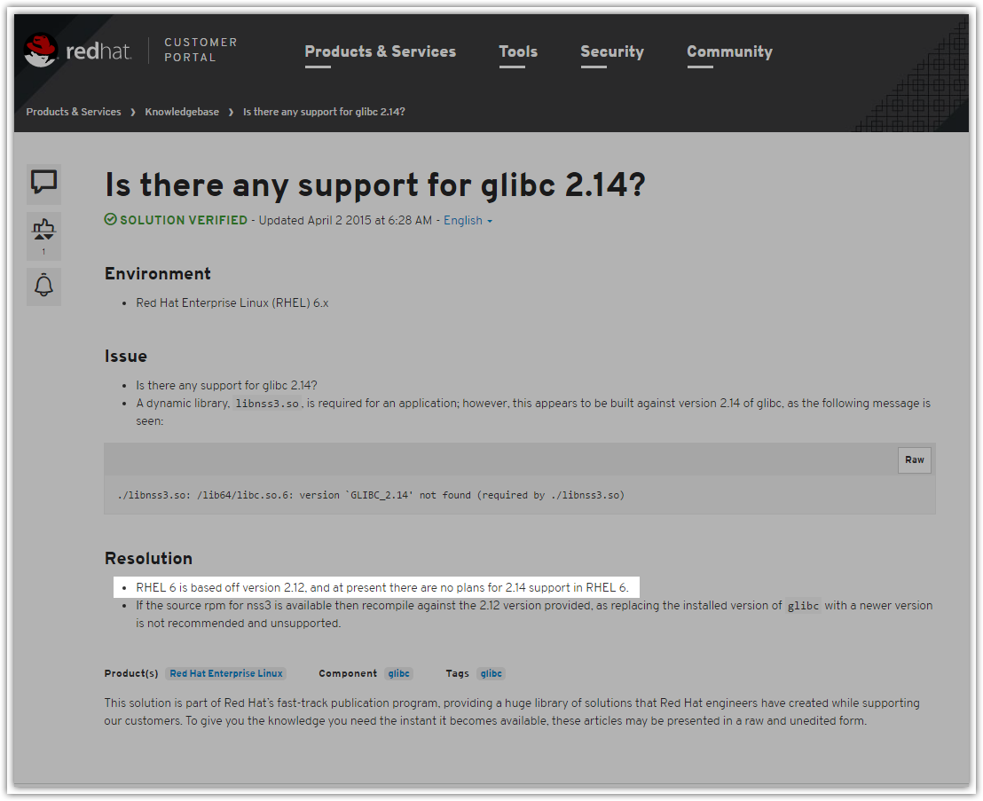

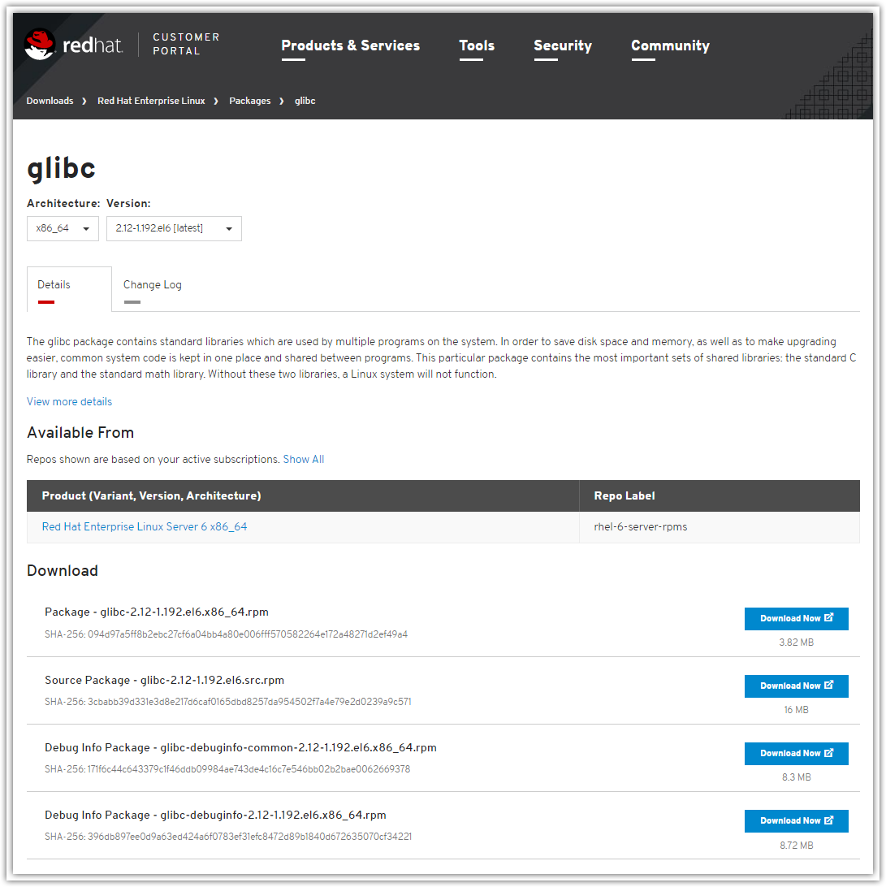

Попытка использовать утилиту dynamo из пакета iometer-2006_07_27.linux.i386-bin.tgz так же натолкнулась на трудности.
Предполагаю, что это связано с использующейся в этом пакете архитектурой i386, в то время как на серверах используется x86-64.

[root@ds-gp-prd-sdw1 tmp]# tar xvf iometer-2006_07_27.linux.i386-bin.tgz
iometer-2006_07_27.linux.i386-bin/
iometer-2006_07_27.linux.i386-bin/src/
iometer-2006_07_27.linux.i386-bin/src/iomtr_kstat/
iometer-2006_07_27.linux.i386-bin/src/iomtr_kstat/iomtr_kstat.h
iometer-2006_07_27.linux.i386-bin/src/iomtr_kstat/Makefile-Linux24
iometer-2006_07_27.linux.i386-bin/src/iomtr_kstat/Makefile-test
iometer-2006_07_27.linux.i386-bin/src/iomtr_kstat/load26.sh
iometer-2006_07_27.linux.i386-bin/src/iomtr_kstat/Makefile-Linux26
iometer-2006_07_27.linux.i386-bin/src/iomtr_kstat/load24.sh
iometer-2006_07_27.linux.i386-bin/src/iomtr_kstat/iomtr_kstat.c
iometer-2006_07_27.linux.i386-bin/src/iomtr_kstat/test.c
iometer-2006_07_27.linux.i386-bin/src/iomtr_kstat/unload.sh
iometer-2006_07_27.linux.i386-bin/src/iomtr_kstat/README.first
iometer-2006_07_27.linux.i386-bin/src/iomtr_kstat/INSTALL
iometer-2006_07_27.linux.i386-bin/src/dynamo
iometer-2006_07_27.linux.i386-bin/src/scripts/
iometer-2006_07_27.linux.i386-bin/src/scripts/iom-indent
iometer-2006_07_27.linux.i386-bin/src/scripts/ccntmknod.README
iometer-2006_07_27.linux.i386-bin/src/scripts/ccntmknod
iometer-2006_07_27.linux.i386-bin/CREDITS
iometer-2006_07_27.linux.i386-bin/CHANGELOG
iometer-2006_07_27.linux.i386-bin/README
iometer-2006_07_27.linux.i386-bin/DEVGUIDE
iometer-2006_07_27.linux.i386-bin/LICENSE
[root@ds-gp-prd-sdw1 tmp]#

[root@ds-gp-prd-sdw1 src]# pwd
/tmp/iometer-2006_07_27.linux.i386-bin/src
[root@ds-gp-prd-sdw1 src]#
[root@ds-gp-prd-sdw1 src]# ./dynamo -i 172.16.28.74 -m 10.216.2.201
-bash: ./dynamo: /lib/ld-linux.so.2: bad ELF interpreter: No such file or directory
[root@ds-gp-prd-sdw1 src]#

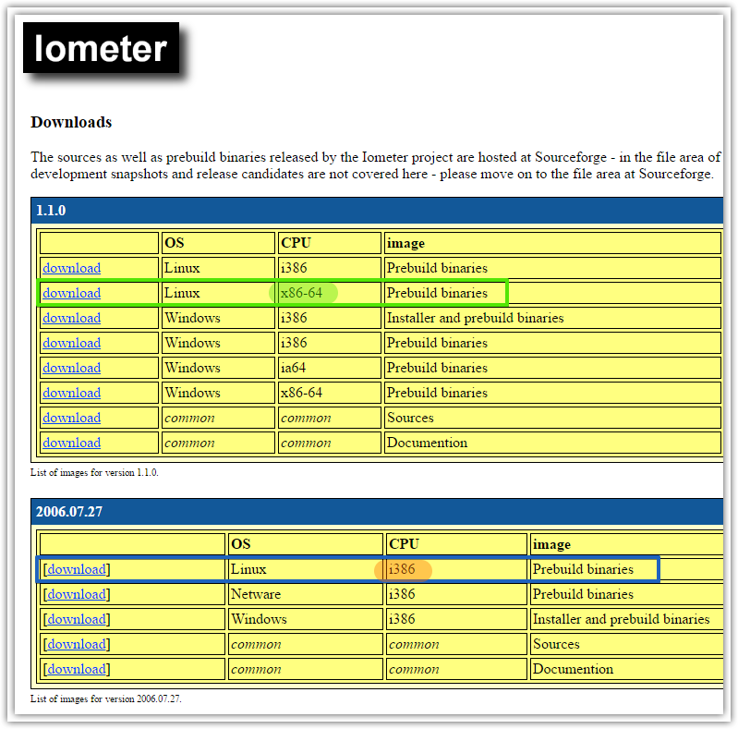
В итоге после установки некоторых пакетов и обновления старых запустить dynamo всё же получилось.

[root@ds-gp-prd-sdw1 src]# ./dynamo -i 172.16.28.74 -m 10.216.2.201
Fail to open kstat device file. You can ignore this warning
unless you are running dynamo on XSCALE CPU.

Command line parameter(s):
Looking for Iometer on "172.16.28.74"

Sending login request...
ds-gp-prd-sdw1
10.216.2.201 (port 25259)

Если использование старой версии iometer отличается от использования новой и если у Вас есть руководство для старой версии – смогли бы Вы его выслать?

http://greg.porter.name/wiki/HowTo:iometer

HowTo:iometer

Contents
[hide]
- 1 Beginner's Guide to iometer
  - 1.1 Getting Started (Iometer on Windows)
    - 1.1.1 Configuring Iometer
    - 1.1.2 Start the Test Run
    - 1.1.3 Usage Notes
  - 1.2 Iometer on Linux
    - 1.2.1 Get Iometer on Windows
    - 1.2.2 Get Dynamo for Linux
    - 1.2.3 Configure or disable firewalls
    - 1.2.4 Start the iometer GUI on the Windows reporting host
    - 1.2.5 Start dynamo on the Linux host under test
    - 1.2.6 Command the Linux host under test with iometer on Windows

Beginner's Guide to iometer
For now, read the manual.
"Iometer is an I/O subsystem measurement and characterization tool for single and clustered systems. It was originally developed by the Intel Corporation and announced at the Intel Developers Forum (IDF) on February 17, 1998 - since then it got wide spread within the industry.
Meanwhile Intel has discontinued to work on Iometer and it was given to the Open Source Development Lab (OSDL). In November 2001, a project was registered at SourceForge.net and an initial drop was provided. Since the relaunch in February 2003, the project is driven by an international group of individuals who are continuesly improving, porting and extend the product."
Iometer rhymes with thermometer.

Getting Started (Iometer on Windows)
The simplest case is to use Iometer on the Windows host that has the disks to test. In this case, you'll be running the Iometer GUI on the Windows host, as well as the Dynamo workload generator on the same host.
The Windows installer will install both pieces, Iometer (GUI) and Dynamo (workload generator).
Get Iometer here. Install it.
On Windows Server 2008, make sure to right-click and "Run as administrator" or Iometer misbehaves. Note that it is "normal" for Iometer to mysteriously open a command prompt window. This is the "Dynamo" process that actually does the disk I/O. Leave this window alone (you can minimize it).
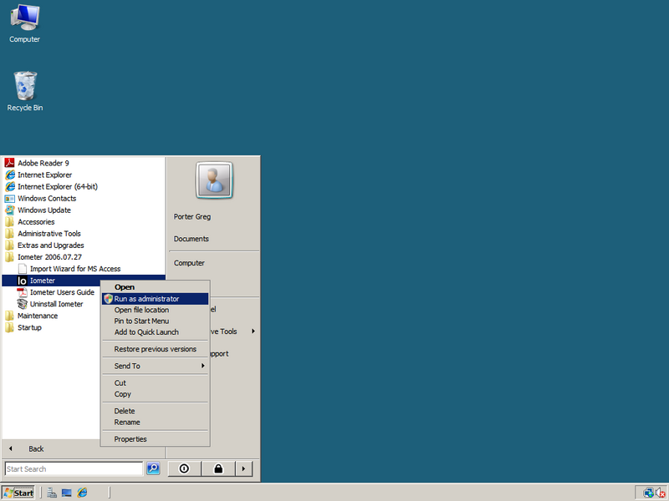
Make sure to run Iometer as administrator.

Configuring Iometer
The basic idea here is to set up one "disk worker" the way you want it, and then clone that worker a number of times. Iometer by default opens 8 disk workers. Delete them all but one with the "Disconnect Selected Worker" button on the top bar.
Once you have just one disk worker, target a "physical" drive (no drive letter) if possible. Just click the check box on the drive you want to target.
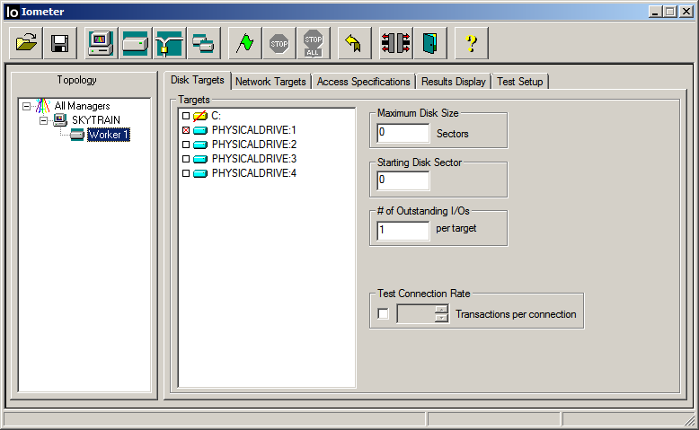
Setting up the first worker, pick the target drive.
Tell the disk worker to use an "Access Specification" (test pattern). I use the "All in one" test pattern.
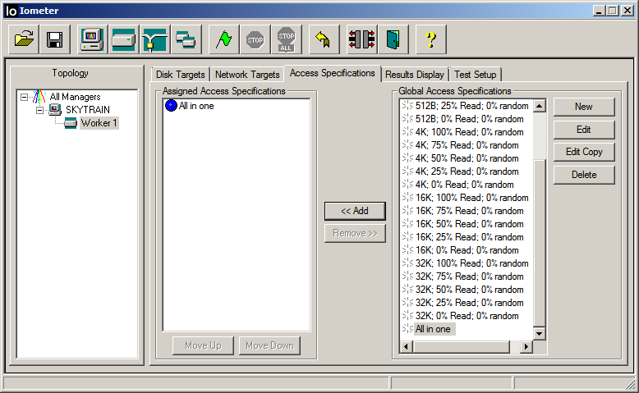
Tell the worker to use "All in one".
Once the first worker is set up, then click the "Start a Duplicate of This Worker" button over and over again to clone the worker. More is better. I use 10 disk workers.
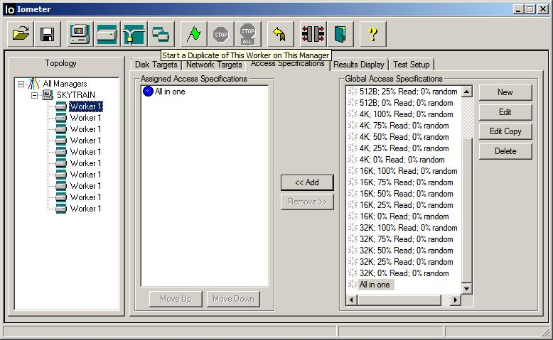
Clone the first worker 9 times.
Click the "Save Test Configuration File" button to save your set up for future runs. I make an Iometer folder in My Documents to hold Iometer files.
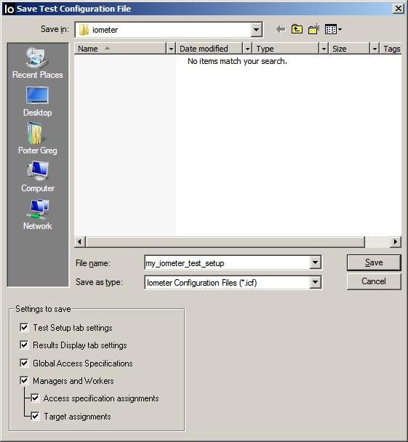
Save your set up.

Start the Test Run
When you're ready, start the test by clicking the "Start Tests" button. It will prompt for a filename to save the results in.
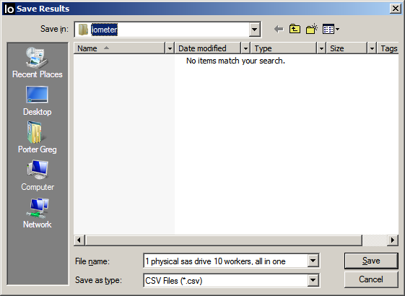
Save your results.

Usage Notes
Don't pay any attention to the numbers until it runs for a while, a half hour or longer. There's all sorts of ram caching whatever going on, so it reports falsely high for a while. If you watch it run, you'll see it start off reporting very large numbers, and they slowly get smaller, and smaller, and smaller. Don't pay any attention to the numbers until they stabilize, might be 30+ minutes.
Waiting a while is even more important when benchmarking a solid state drive (SSD). Benchmarking these is notoriously inaccurate, basically because SSD makers know you’re going to do it, and tweak the SSD’s so they behave very well in the first few minutes. They know the average person will probably do some quickie benchmark on the SSD in the first few minutes of use, so they make sure the SSD is configured to respond quickly during initial use.
You can get past this by running the benchmark for a few hours, at least 8 hours or overnight. If you watch the results over time, you’ll see the SSD performance drop by 50% or more from the initial numbers. Of course the initial numbers are what the manufacturer puts in the specs and on the box. Basically, they lie.
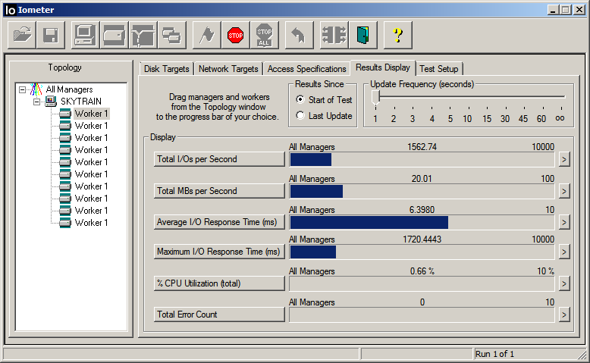
Live results.

Iometer on Linux
Iometer has 2 basic pieces, Iometer and Dynamo. The GUI (Iometer) is run on a Windows host. It is possible to load the Dynamo workload generator on another host, say a Linux host. In this case, the Linux host running Dynamo is the machine under test, and the Windows host running the Iometer GUI is just reporting the numbers.

Get Iometer on Windows
Same steps as above. The Iometer GUI has to be run on Windows. So if a Linux host has the disks you want to test, you'll have to have 2 hosts, one Windows host to run the Iometer GUI on, and the Linux host(s) to test the disks on.

Get Dynamo for Linux
I successfully did this on 32 bit CentOS 5.4. It was straightforward. Hopefully it will work on your distro of choice. The basic steps are: Get the tarball and unpack the tarball.
Figure out first where you want to put iometer. I decided to put it in /opt. I downloaded the binary Linux tarball in opt and unpacked it.
[root@crimson ~]# cd /opt
[root@crimson opt]# ls
[root@crimson opt]# wget http://prdownloads.sourceforge.net/iometer/iometer-2006_07_27.linux.i386-bin.tgz
--2010-11-22 09:51:16-- http://prdownloads.sourceforge.net/iometer/iometer-2006_07_27.linux.i386-bin.tgz
Resolving prdownloads.sourceforge.net... 216.34.181.59
Connecting to prdownloads.sourceforge.net|216.34.181.59|:80... connected.
HTTP request sent, awaiting response... 301 Moved Permanently
Location: http://downloads.sourceforge.net/project/iometer/iometer-stable/2006-07-27/iometer-2006_07_27.linux.i386-bin.tgz [following]
--2010-11-22 09:51:16-- http://downloads.sourceforge.net/project/iometer/iometer-stable/2006-07-27/iometer-2006_07_27.linux.i386-bin.tgz
Resolving downloads.sourceforge.net... 216.34.181.59
Reusing existing connection to prdownloads.sourceforge.net:80.
HTTP request sent, awaiting response... 302 Found
Location: http://superb-sea2.dl.sourceforge.net/project/iometer/iometer-stable/2006-07-27/iometer-2006_07_27.linux.i386-bin.tgz [following]
--2010-11-22 09:51:16-- http://superb-sea2.dl.sourceforge.net/project/iometer/iometer-stable/2006-07-27/iometer-2006_07_27.linux.i386-bin.tgz
Resolving superb-sea2.dl.sourceforge.net... 209.160.57.180
Connecting to superb-sea2.dl.sourceforge.net|209.160.57.180|:80... connected.
HTTP request sent, awaiting response... 200 OK
Length: 82634 (81K) [application/octet-stream]
Saving to: `iometer-2006_07_27.linux.i386-bin.tgz'
100%[======================================>] 82,634 515K/s in 0.2s
2010-11-22 09:51:16 (515 KB/s) - `iometer-2006_07_27.linux.i386-bin.tgz' saved [82634/82634]
[root@crimson opt]# gunzip iometer-2006_07_27.linux.i386-bin.tgz
[root@crimson opt]# tar -xvf iometer-2006_07_27.linux.i386-bin.tar
iometer-2006_07_27.linux.i386-bin/
iometer-2006_07_27.linux.i386-bin/src/
iometer-2006_07_27.linux.i386-bin/src/iomtr_kstat/
iometer-2006_07_27.linux.i386-bin/src/iomtr_kstat/iomtr_kstat.h
iometer-2006_07_27.linux.i386-bin/src/iomtr_kstat/Makefile-Linux24
iometer-2006_07_27.linux.i386-bin/src/iomtr_kstat/Makefile-test
iometer-2006_07_27.linux.i386-bin/src/iomtr_kstat/load26.sh
iometer-2006_07_27.linux.i386-bin/src/iomtr_kstat/Makefile-Linux26
iometer-2006_07_27.linux.i386-bin/src/iomtr_kstat/load24.sh
iometer-2006_07_27.linux.i386-bin/src/iomtr_kstat/iomtr_kstat.c
iometer-2006_07_27.linux.i386-bin/src/iomtr_kstat/test.c
iometer-2006_07_27.linux.i386-bin/src/iomtr_kstat/unload.sh
iometer-2006_07_27.linux.i386-bin/src/iomtr_kstat/README.first
iometer-2006_07_27.linux.i386-bin/src/iomtr_kstat/INSTALL
iometer-2006_07_27.linux.i386-bin/src/dynamo
iometer-2006_07_27.linux.i386-bin/src/scripts/
iometer-2006_07_27.linux.i386-bin/src/scripts/iom-indent
iometer-2006_07_27.linux.i386-bin/src/scripts/ccntmknod.README
iometer-2006_07_27.linux.i386-bin/src/scripts/ccntmknod
iometer-2006_07_27.linux.i386-bin/CREDITS
iometer-2006_07_27.linux.i386-bin/CHANGELOG
iometer-2006_07_27.linux.i386-bin/README
iometer-2006_07_27.linux.i386-bin/DEVGUIDE
iometer-2006_07_27.linux.i386-bin/LICENSE
[root@crimson opt]# cd iometer-2006_07_27.linux.i386-bin
[root@crimson iometer-2006_07_27.linux.i386-bin]#
[root@crimson iometer-2006_07_27.linux.i386-bin]# ls
CHANGELOG CREDITS DEVGUIDE LICENSE README src
[root@crimson iometer-2006_07_27.linux.i386-bin]# cd src
[root@crimson src]# ls -al
total 156
drwxrwxr-x 4 portergl portergl 4096 Sep 29 2006 .
drwxrwxr-x 3 portergl portergl 4096 Sep 29 2006 ..
-rwxrwxr-x 1 portergl portergl 117864 Sep 29 2006 dynamo
drwxrwxr-x 2 portergl portergl 4096 Sep 29 2006 iomtr_kstat
drwxrwxr-x 2 portergl portergl 4096 Sep 29 2006 scripts
That's it (at least on 32 bit CentOS 5.4). You now have a ready to run dynamo executable.

Configure or disable firewalls
The Dynamo executable on your Linux host under test is going to be commanded by, and report numbers to, the Windows host running Iometer across the network. Obviously, the network ports used for this need to be open. Dynamo uses random high ports. I fiddled a bit with trying to appropriately open the right ports, and then gave up. I just flat turned all firewalls off, both the host firewall on my Linux host (I used 'service iptables stop') as well as the host firewall on Windows.

Start the iometer GUI on the Windows reporting host
Just start Iometer. The GUI will start and wait for Dynamo exectutables to connect to it.

Start dynamo on the Linux host under test
Easy. At a minimum you need to specify 2 parameters. You need to tell Dynamo the name or IP of the Windows host running Iometer (-i) and the name to use for the Linux host under test (-m). In the example below, my Windows host is maroon, and the Linux host under test is crimson.
When it starts, you'll get some whining like "Fail to open kstat device file. You can ignore this warning unless you are running dynamo on XSCALE CPU." I ignored this.
[root@crimson src]# ./dynamo -i maroon -m crimson &
[1] 4960
[root@crimson src]# Fail to open kstat device file. You can ignore this warning
unless you are running dynamo on XSCALE CPU.
Command line parameter(s):
Looking for Iometer on "maroon"
Sending login request...
crimson.csc.calpoly.edu
crimson (port 54781)
Successful PortTCP::Connect
- port name: maroon
*** If dynamo and iometer hangs here, please make sure
*** you use a correct -m <manager_computer_name> that
*** can ping from iometer machine. use IP if need.
Login accepted.
Reporting drive information...
Set_Sizes: Open on "/sys/iobw.tst" failed (error Permission denied).
Set_Sizes: Open on "/dev/shm/iobw.tst" failed (error Invalid argument).
Set_Sizes: Open on "/proc/sys/fs/binfmt_misc/iobw.tst" failed (error Permission denied).
Physical drives (raw devices)...
Set_Sizes: Open on "/dev/dm-0" failed (error No such file or directory).
Set_Sizes: Open on "/dev/dm-1" failed (error No such file or directory).
Reporting TCP network information...
done.

Command the Linux host under test with iometer on Windows
If it all is working, it should work exactly like above. The only difference now is that you'll see a Dynamo manager and worker(s) on the Linux host, in addition to a manager on the Windows host running Iometer. You can configure and run tests on the remote Linux host just as you did above on the local Windows host.
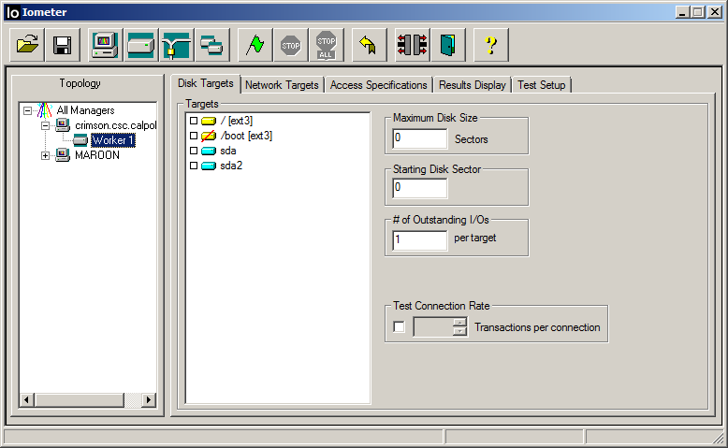
Command your Linux host under test from Windows.
When you configure your workers and start the test, you may get an error dialog like this. I picked "Yes" and ignored it. My tests seemed to run fine anyway.
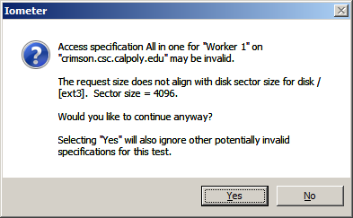
Ignore this error.
Iometer on Linux!
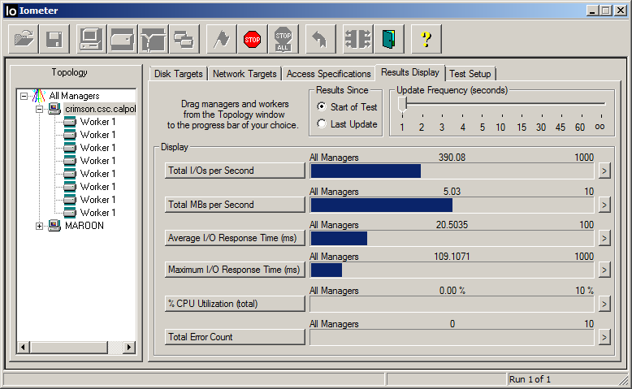
Linux host under test.

http://iometer.996274.n3.nabble.com/help-the-port-between-iometer-and-dynamo-td342.html

help:the port between iometer and dynamo

classic Classic list List threaded Threaded
3 messages Options Options
alian921 Reply | Threaded | More
Selected post Aug 11, 2006; 12:02pm help:the port between iometer and dynamo
alian921
4 posts
Could you tell me the port between iometer and dynamo.Is it the TCP 1066 port?
I will have a test between linux server(dynamo) and windows server(iometer.exe),and I have to set the iptables.Could you tell me the port?
Remove Ads
Ming Zhang Reply | Threaded | More
Aug 11, 2006; 3:51pm Re: help:the port between iometer and dynamo
Ming Zhang
448 posts
On Fri, 2006-08-11 at 01:02 -0700, alian921 wrote:
> Could you tell me the port between iometer and dynamo.Is it the TCP 1066
> port?

iometer listen on 1066. but dynamo will listen on a random port? i
suggest u to turn off firewall for this. or have to check the code to
set a fixed port for dynamo.

the design is iometer listen on 1066 to get dynamo connection, then
dynamo will tell iometer to connect to dynamo with a port, iometer will
connect. so finally there are two connections. i do not know why
original design is like this. but it is.

Ming

> I will have a test between linux server(dynamo) and windows
> server(iometer.exe),and I have to set the iptables.Could you tel iomell me the
> port?
>

-------------------------------------------------------------------------
Using Tomcat but need to do more? Need to support web services, security?
Get stuff done quickly with pre-integrated technology to make your job easier
Download IBM WebSphere Application Server v.1.0.1 based on Apache Geronimo
http://sel.as-us.falkag.net/sel?cmd=lnk&kid=120709&bid=263057&dat=121642
_______________________________________________
Iometer-user mailing list
[hidden email]
https://lists.sourceforge.net/lists/listinfo/iometer-user
alian921 Reply | Threaded | More
Aug 12, 2006; 8:10am Re: help:the port between iometer and dynamo
alian921
4 posts
Hi ming,Thank you very much

-------------------------------------------------------------------------
Using Tomcat but need to do more? Need to support web services, security?
Get stuff done quickly with pre-integrated technology to make your job easier
Download IBM WebSphere Application Server v.1.0.1 based on Apache Geronimo
http://sel.as-us.falkag.net/sel?cmd=lnk&kid=120709&bid=263057&dat=121642
_______________________________________________
Iometer-user mailing list
Iometer-user@lists.sourceforge.net
https://lists.sourceforge.net/lists/listinfo/iometer-user

#
# Here is a link of resourse, that allow to see results of iometer.
#
http://vmktree.org/iometer/

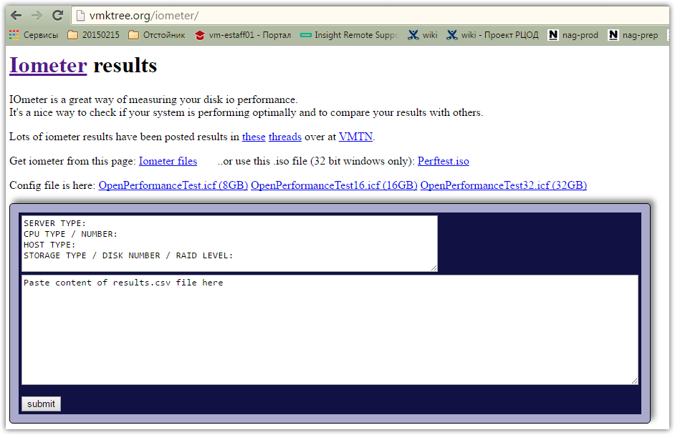

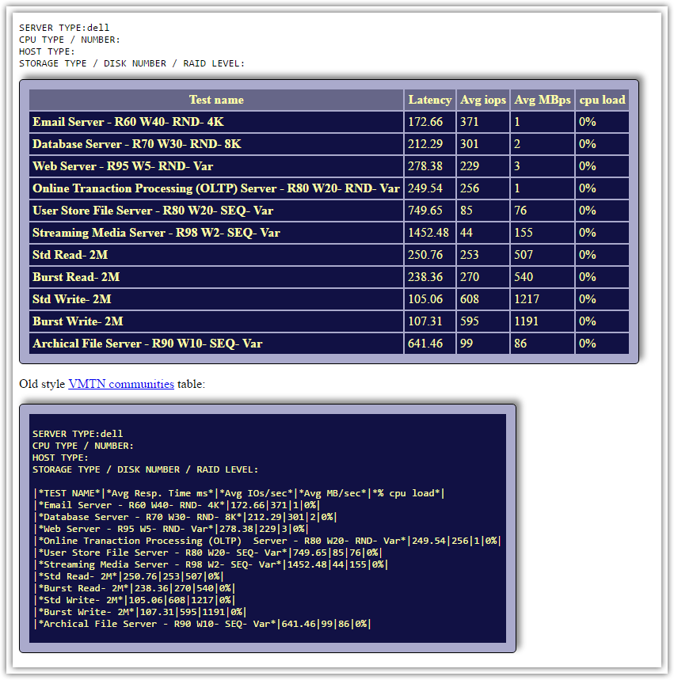

http://docs.nexenta.com/NexentaRH/NexentaRH/server/NC4H_3.0_en/projects/NC4H/mergedProjects/NexentaConnect%20for%20Horizon%20User%20Guide/nxvdi_usguide/nxvdi_bencmark_test/Understanding_IOMeter_Benchmark_Results.htm

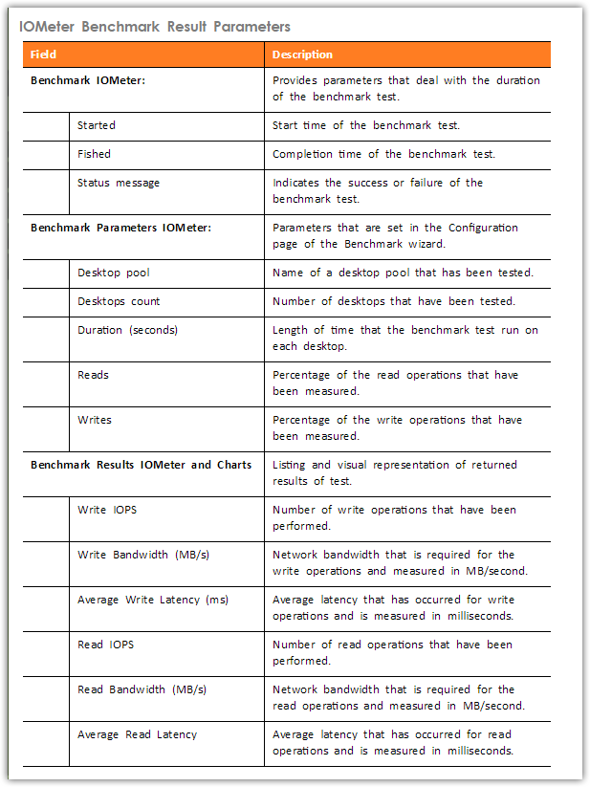

The following table describes the IOMeter benchmark result parameters.
Field |  | Description
Benchmark IOMeter: |  | Provides parameters that deal with the duration of the benchmark test.
 | Started | Start time of the benchmark test.
 | Fished | Completion time of the benchmark test.
 | Status message | Indicates the success or failure of the benchmark test.
Benchmark Parameters IOMeter: |  | Parameters that are set in the Configuration page of the Benchmark wizard.
 | Desktop pool | Name of a desktop pool that has been tested.
 | Desktops count | Number of desktops that have been tested.
 | Duration (seconds) | Length of time that the benchmark test run on each desktop.
 | Reads | Percentage of the read operations that have been measured.
 | Writes | Percentage of the write operations that have been measured.
Benchmark Results IOMeter and Charts |  | Listing and visual representation of returned results of test.
 | Write IOPS | Number of write operations that have been performed.
 | Write Bandwidth (MB/s) | Network bandwidth that is required for the write operations and measured in MB/second.
 | Average Write Latency (ms) | Average latency that has occurred for write operations and is measured in milliseconds.
 | Read IOPS | Number of read operations that have been performed.
 | Read Bandwidth (MB/s) | Network bandwidth that is required for the read operations and measured in MB/second.
 | Average Read Latency | Average latency that has occurred for read operations and is measured in milliseconds.

